Workshop on Integrated Planning of Inland Waterways Transport (IWT) Projects
press release

Vukovar, 28-29th September 2017 – a two-day workshop was held at the premises of the Croatian Agency for Inland Waterways, regarding the Mixed Environment Transport External Expert Team (METEET) on Integrated Planning of Inland Waterways Transport (IWT) Projects. The goal of this initiative was to assist the competent inland waterway transport authorities on a voluntary basis with the objective to foster an integrated approach when developing infrastructural projects in the field of inland navigation.
The METEET project is managed by a Steering Committee composed of representatives from the Danube Commission Secretariat, International Commission for the Protection of the Danube River (ICPDR) Secretariat, and the European Commission services (DG MOVE, DG ENV and DG REGIO), as well as the International Sava River Basin Commission (ISRBC) as observer. The activity is financed by the European Commission.

The Workshop was guided by two external experts from two fields, transport and environment, observed by the European Commission, Danube Commission, ICPDR, and ISRBC.
Representatives from Agency for Inland Waterways, Ministry of the Sea, Transport and Infrastructure, Croatian Agency for Environment and Nature, Croatian Waters, Port Authorities, and Ministry of Regional Development and EU Funds during two days gained general knowledge regarding European Legislation (on transport and environment),as well as the Platina Manual on good practices in sustainable waterway planning, and Joint Statement on Guiding Principles for the Development of Inland Navigation and Environmental Protection in the Danube River Basin.

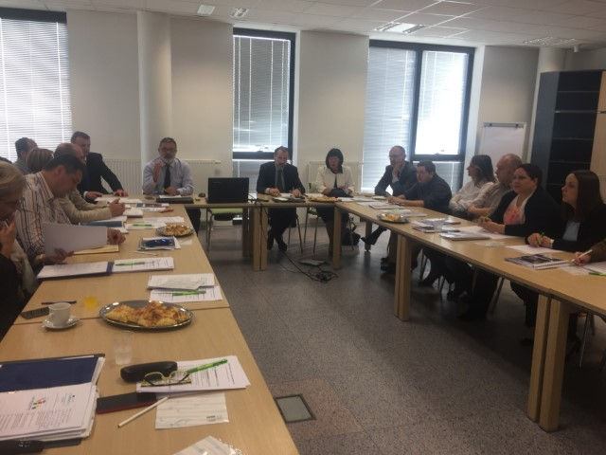

Desiree Oen (DG Move): ‘’METEET is important as a pilot project’’
‘’Think about both sides, transport and environment, working together’’
Petar Margić (DC): ’’The key objective of METEET project is giving support during planning and implementation of inland waterways projects’’
Ivan Zavadsky (ICPDR): ‘’problems in the lack of cooperation between transport and environment which leads to difficulties. We need to work together''
Neven Trenc (Agency for Environment and Nature): ‘’early engagement of experts helps avoiding some of the problems during project drafting’’

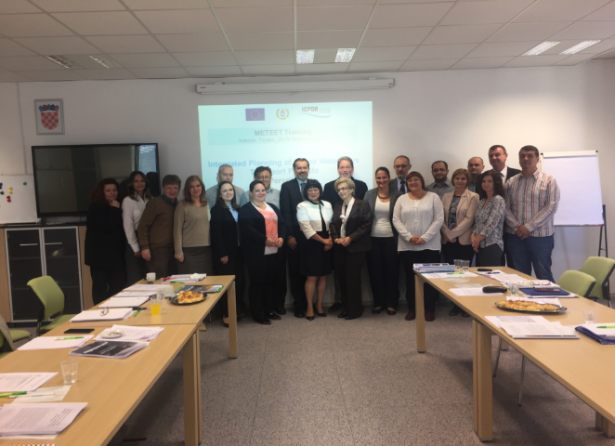

As the result, the participants worked on virtual inland waterway project, taking into account all useful information and gained knowledge during two-day workshop. Purpose of this virtual project was to motivate participants to define, on their own, steps in project preparation, and identify potential stakeholders who would be involved in successful implementation of project of interest for improvement of navigation conditions on inland waterways.

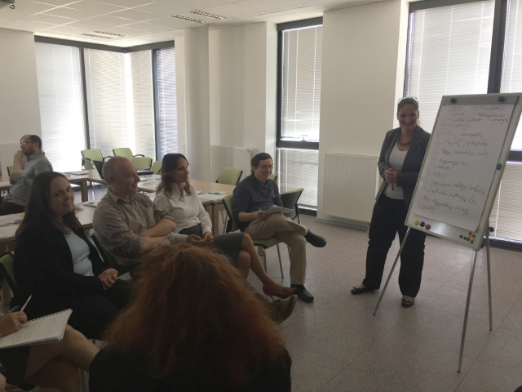 | 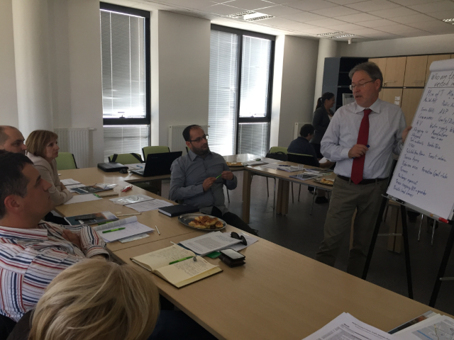

The aim of the Workshop which was to provide guidance to competent authorities in addressing environmental issues that may arise during the planning and implementation of inland navigation projects in the Danube Region, taking into account European Environmental Legislation is reached.
All participants found Workshop extremely useful emphasizing on all good advice, guidance and presentations provided by experts. Newly gained knowledge will be extremely useful in future integrated planning of inland navigation projects.

